Measuring disbursement efficacy of Universal Service Funds: Case studies from India, Malaysia, Pakistan & Sri Lanka

Policy Brief

Most universal-service funds draw resources from consumers of ICT services. Unless the funds are disbursed, the intended policy objectives cannot be achieved. If policymakers and stakeholders fully understand the actual performance of the funds both with regard to the satisfying the necessary condition of getting the money out in a timely manner and with regard to whether those funds are applied effectively for the stated purposes, the current low performance of funds and programs across multiple countries may be remedied. Two metrics, the accumulated disbursement rate (ADR) and the year-on-year disbursement rate (YDR) are proposed. They can be compiled for all countries based on relatively simple data that are in the public domain (or should be). They will allow performance to be compared across countries and across time. The YDR is most forgiving to fund administrators in measuring how much of the inflows in the immediately prior year have been disbursed. An ADR that approaches 100 percent is the ideal
SUMMARY OF RECOMMENDATIONS

- Compile ADRs and YDRs for all countries with universal-service programs, or for subsets that have comparative or persuasive value. The proposed metrics may be easily be applied to document the necessary conditions of performance.
- Develop acceptable and broadly objective accounts of how the funds have been expended. Even in instances where funds are being disbursed, it is important to assess whether the disbursements are for stated purposes.
- Take remedial actions to improve necessary and sufficient conditions of performance or reduce inflows. Based on the conclusions drawn from the assessments remedial action can be taken. .
THE RESEARCH

Universal service funds are failing
There is considerable criticism of a journalistic nature about the poor performance of universal service funds, especially in terms of funds in the range of USD billions unspent. However there has been little systematic documentation of these alleged failings. The proposed metrics fill this gap.

Application of metrics to different countries yield valuable insights
The application of the metrics to diverse cases shows that useful insights can be gained. For example, Pakistan is generally perceived as having had an exemplary universal-service fund, at least for a few years. But the actual disbursements, both year-on-year and accumulated, portray a different picture (Figure 1). Early performance in most funds is good, but declines. This results in a downward trajectory for the ADR, except for Malaysia (Figure 2). In this case, the disbursement performance improves as results of several years of good year-on-year performance.

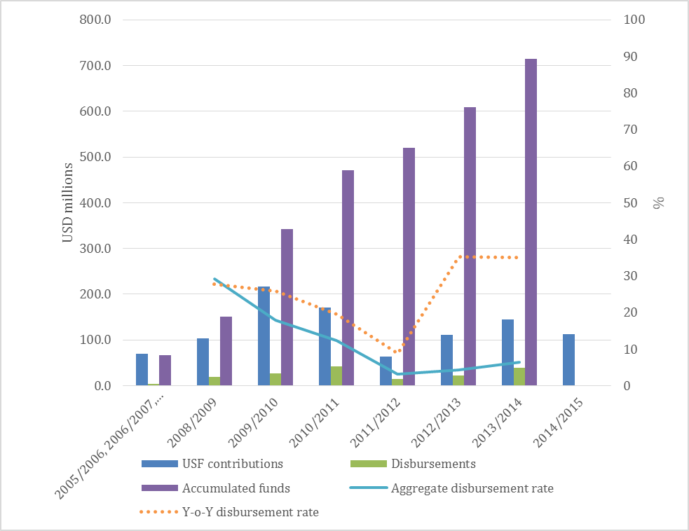
Figure 1. Disbursement performance of Pakistan universal service fund

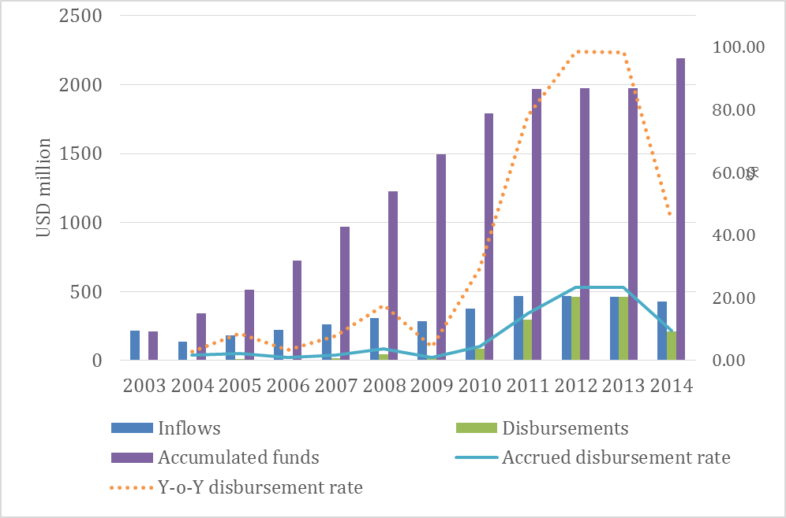
Figure 2: Disbursement performance of Pakistan universal service fund

SOURCES
Can be included within the 2-page limit. Follow APA format. Following was used as the basis for the present guide:
Knowledge Management International Conference and Exposition (2012). Paper Format for the Proceeding of KMICe2012. http://kmice.cms.net.my/submission.asp (accessed August 2012)

AUTHOR/S

Sujata N Gamage | Human Capital Research Program, LIRNEasia | 12 Balcombe Place, Colombo 00800, Sri Lanka | Tel Fax +94 11 267 1075 | sujata@lirneasia.net | www.lirneasia.net
Author2 | Department, Organization | Street Address, Country| Telephone/fax | Email | URL

