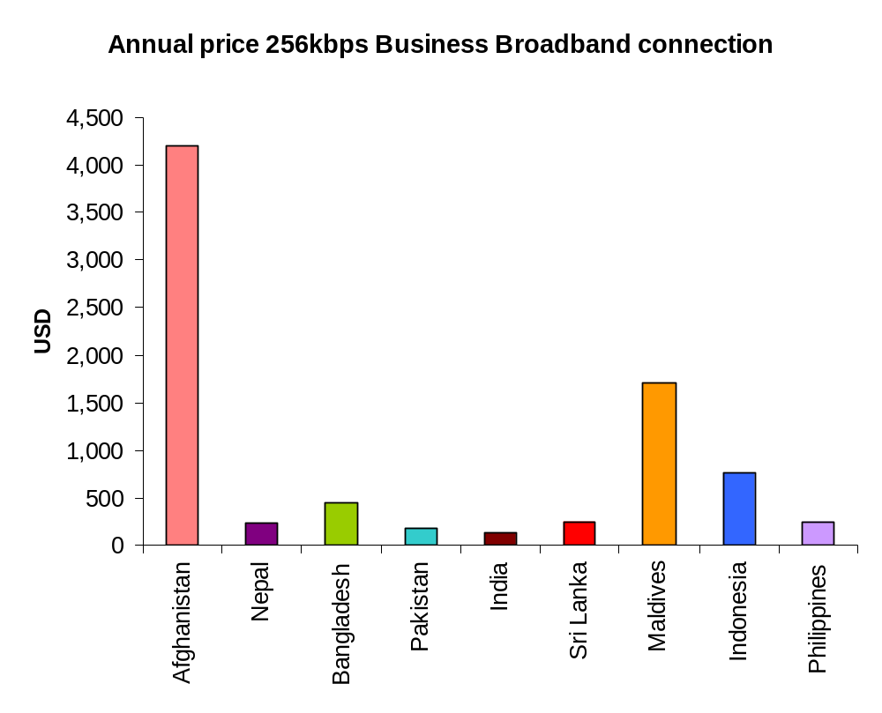
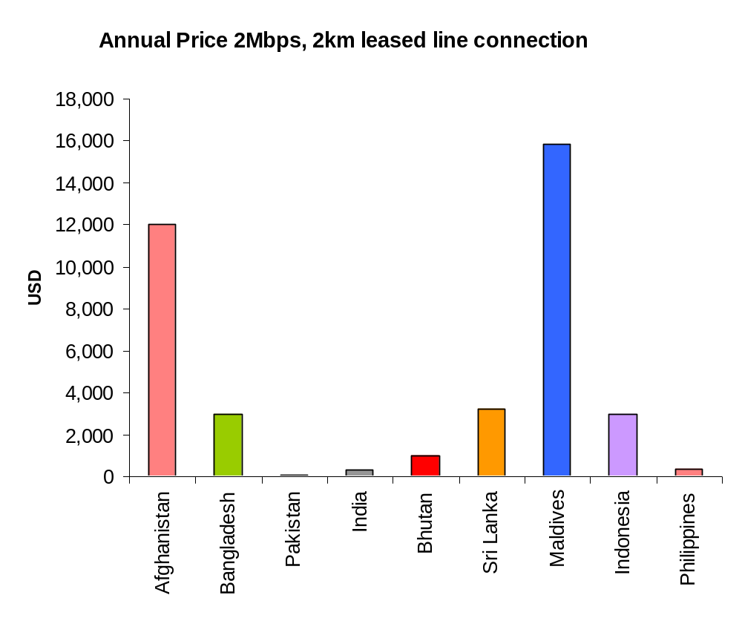
www.lirneasia.net
Figure 2
Figure 1

Figure 1

Table 1- Broadband Prices in Emerging Asia in USD

Country | Annual cost, 2Mbps, 2km DPLC (tail cost) | Annual cost, 2Mbps, 100km DPLC | Annual cost, 2Mbps Broadband business connection (unlimited download) | Annual cost, 256kbps Broadband business connectionError: Reference source not found (unlimited download) | Annual cost, 256kbps Broadband residential connectionError: Reference source not found (unlimited download) | Price per GB, for 2Mbps, 5-10 GB data limit (Business) | Price per GB, for 256kbps, 5-10 GB data limit (Business) | Price per GB, for 256kbps, 1- 4 GB data limit (Residential) | Price per GB, 1Mbps speed, 1GB data limit mobile internet  www.lirneasia.net
South Asia
Afghanistan | 12,000 | - | 11,700 | 4,200 | 4,200Error: Reference source not found | - | - | - | -
Nepal | - | - | 1,567 | 238 | 238Error: Reference source not found | - | - | - | -
Bangladesh | 3,000 | -Error: Reference source not found | - | 444 | 267 | - | - | - | -
Pakistan | 38 | 1,924 | 761 | 187 | 187Error: Reference source not found | - | 2.70 | 2.14 | 2.24
India | 330 | 3,423 | 3,491 | 139 | 145 | 3.05 | - | 5.08 | -
Bhutan | 986 | 7,392 | - | - | - | 4.21 | 4.33 | 4.03 | 17.54
Sri Lanka | 3,249 | 6,350 | 557 | 251 | 251Error: Reference source not found | - | - | 9.10 | 9.10
Maldives | 15,865 | 41,422Error: Reference source not found | 3,789 | 1,709 | 379 | 22.9 | 10.29 | 9.50 | -
South East Asia
Indonesia | 2,958 | 8,330 | - | 765 | 765Error: Reference source not found | 21 | 17 | 17Error: Reference source not found | 26.16
Philippines | 392 | -Error: Reference source not found | 495 | 256 | 256 | - | - | - | -

Broadband Quality of Service Experience (QoSE) Indicators
www.lirneasia.net

Price is not the only dimension that is of interest to customers and regulators. Quality of Service Experience (QoSE) is integrally connected to price: an increase in quality is an invisible decrease in price and vice versa.

Broadband quality can be evaluated through speed tests. Test sites provide a variety of information about the speed of a link. Careful design and implementation of tests can shed light on the exact segment where inadequate capacity constrains speed. Carefully implemented tests can also be the basis for Service Level Agreements (SLAs) between operators and users and for regulatory action.

In the present tests, the methodology has been developed in collaboration with a team headed by Professor Timothy Gonsalves of IIT Madras. The following dimensions of quality have been measured for two networks each in India (Chennai) and Sri Lanka (Colombo). Depending on the feedback that is received, the test methodology will be improved and extended to a larger number of locations, the objective being the development of Broadband QOSE indicators for South Asia.

Throughput (kbps) | Referred to as the “actual amount of useful data sent on a transmission”. Defined by the ITU as “an amount of user information transferred in a period of time” (ITU-T X.641 (97), 6.3.3.16), more commonly referred to as download or upload speeds.  A key advertised metrics in broadband services is the download speed. It defines how much information a user can received from a local or international server. Upload speed defines the speed in which the user can send information to local or international servers. It plays a significant role in responsiveness and real-time applications like VOIP (Voice Over Internet Protocol).  Throughput, or download and upload speeds, varies depending on the location of the server that holds the content. If the location is local, such as an ISP server, the throughput may be higher than it would be if the location is international.  Therefore the testing has included throughput for both local (ISP) and international (yahoo.com) servers.
Latency (ms) | “Latency refers to delays when voice packets transverse the network”. It is measured in milliseconds by using the Round Trip Time (RTT). This is significant in systems that require two-way interactive communication, such as voice telephony, or ACK/NAK [acknowledge/not acknowledge] data systems where the round-trip time directly affects the throughput rate, such as the Transmission Control Protocol (TCP).  The ITU definition states that “Latency means transmission delay for FEC (Forwarding Equivalence Class) encoding, decoding, interleaving and de-interleaving” (ITU-T G.972 (04), 3025).  www.lirneasia.net
Jitter (ms) | “Jitter is uneven latency and packet loss”. It is the variation of end-to-end delay from one packet to the next within the same packet stream/connection/flow. Jitter is more relevant for real-time traffic like VOIP. Ideally the figure should be low.  E.g. Radio quality voice requires less than 1 ms Jitter, toll-quality voice requires less than 20 ms jitter, normal VoIP requires jitter to be less than  30 ms. Beyond 30 ms, VoIP performance will degrade.  Also defined by ITU as “Short-term non-cumulative variations of the significant instants of a digital signal from their ideal positions in time” (ITU-T G.701 (93), 2024).
Packet Loss (%) | Number of packets (as a percentage) that does not reach the destination. Degradation can result in noticeable performance loss with streaming technologies, VOIP and video conferencing. ITU states that “In general, IP-based networks do not guarantee delivery of packets. Packets will be dropped under peak loads and during periods of congestion. NOTE – In case of multimedia services, when a late packet finally arrives, it will be considered lost” (ITU-T H.360 (04), 5.3.2.2).

Results of QoSE testing

Fixed Broadband - Download Speed
www.lirneasia.net

Figure 3 Figure 4
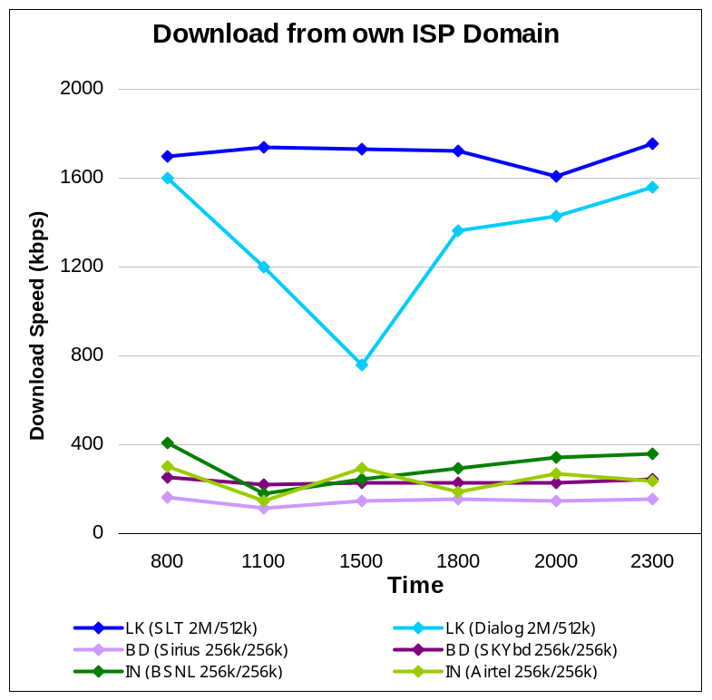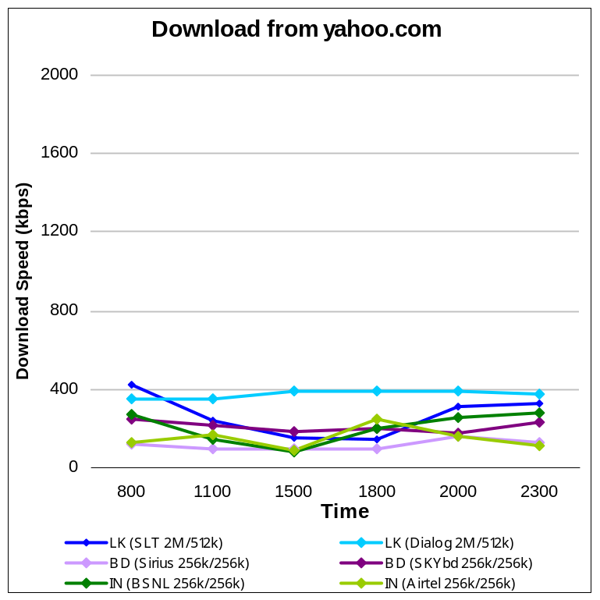

Figure 5 Figure 6
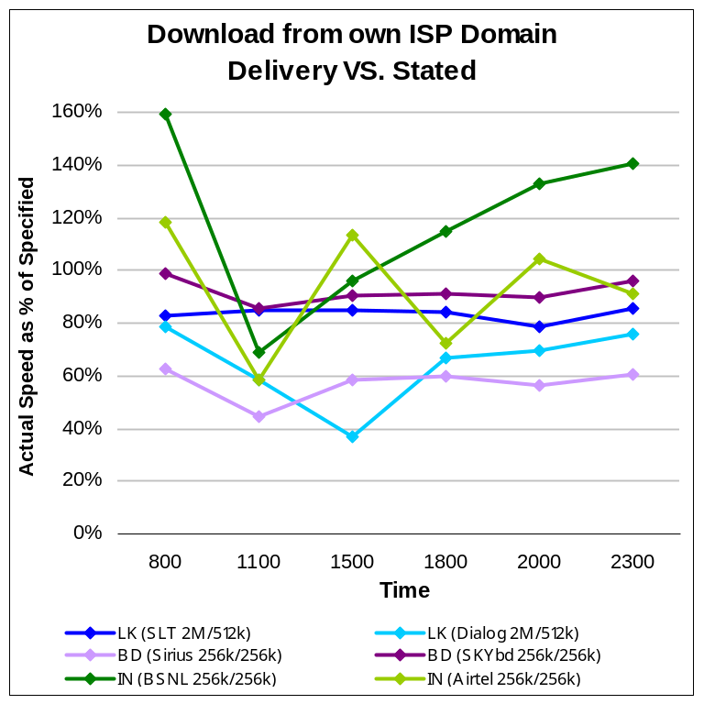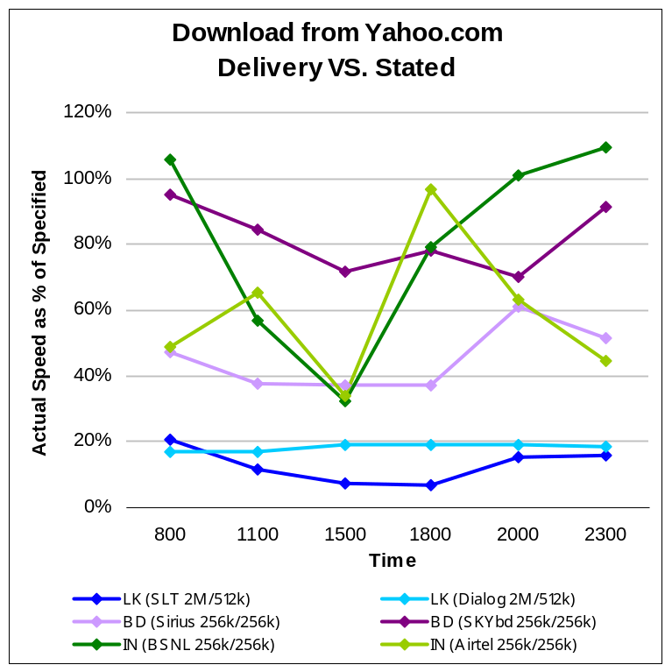
www.lirneasia.net

Maximum promised speed

Maximum promised speed

Fixed Broadband - Jitter and Packet Loss

Figure 7 Figure 8Error: Reference source not found
www.lirneasia.net
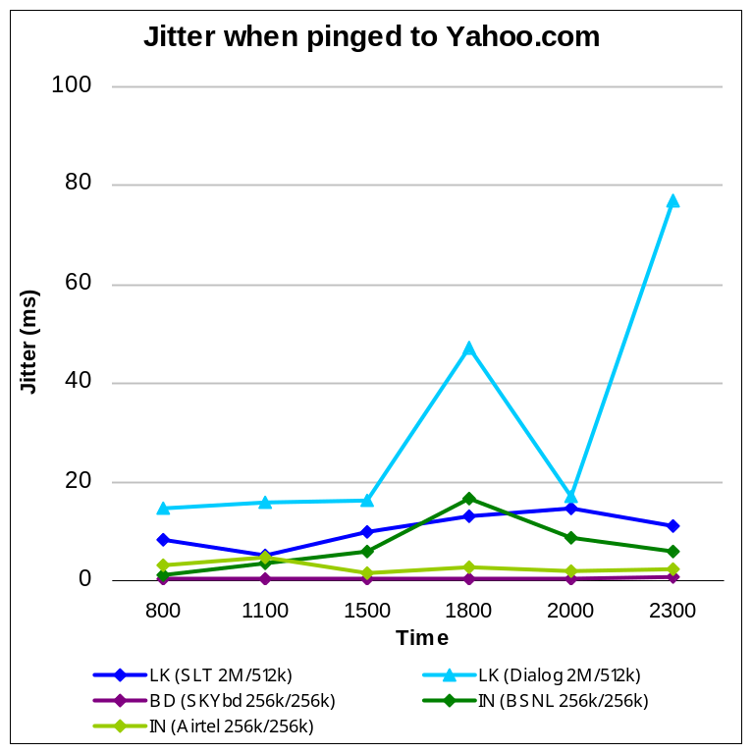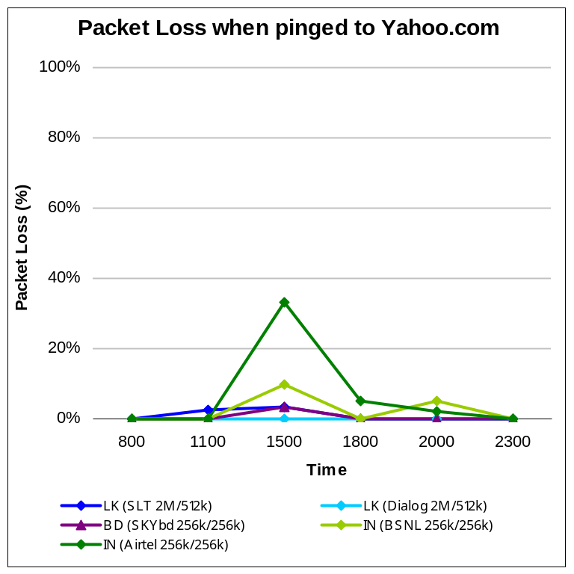

3%

Lower the better

Fixed Broadband - Latency

Figure 9Error: Reference source not found
www.lirneasia.net
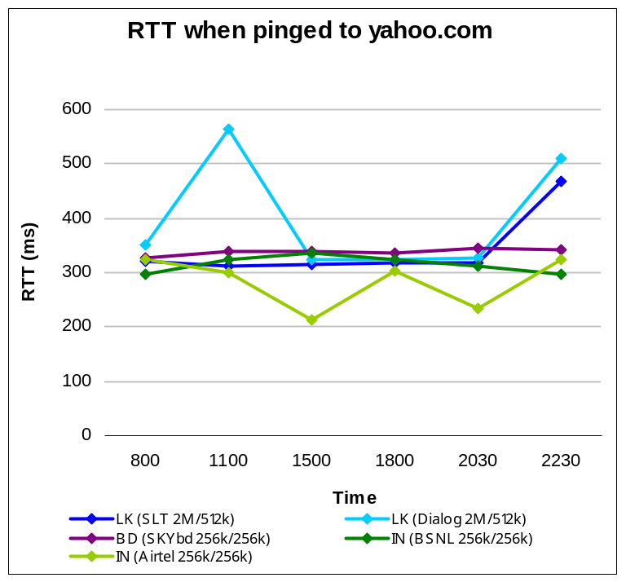

300ms

Lower the better

Mobile Broadband – Download Speed

Figure 10 Figure 11
www.lirneasia.net
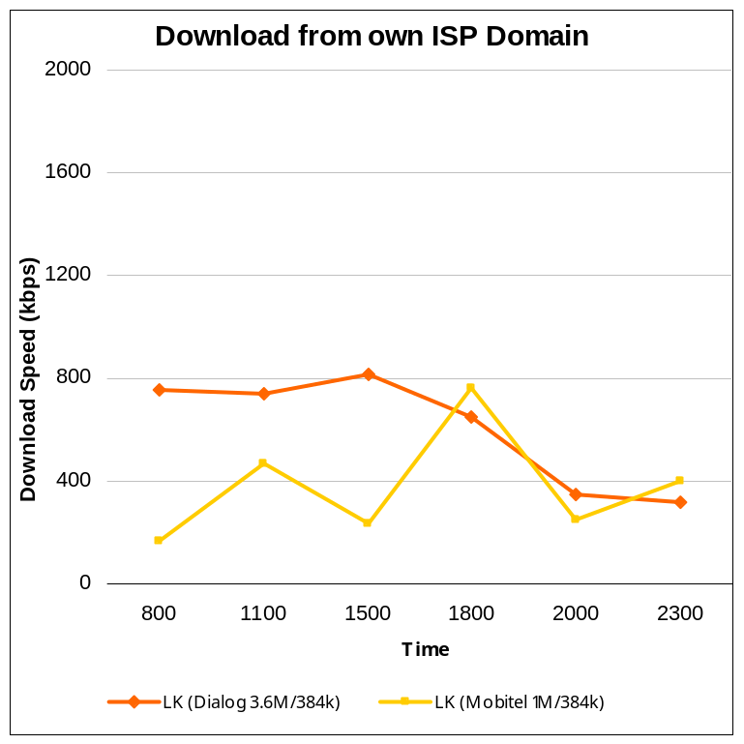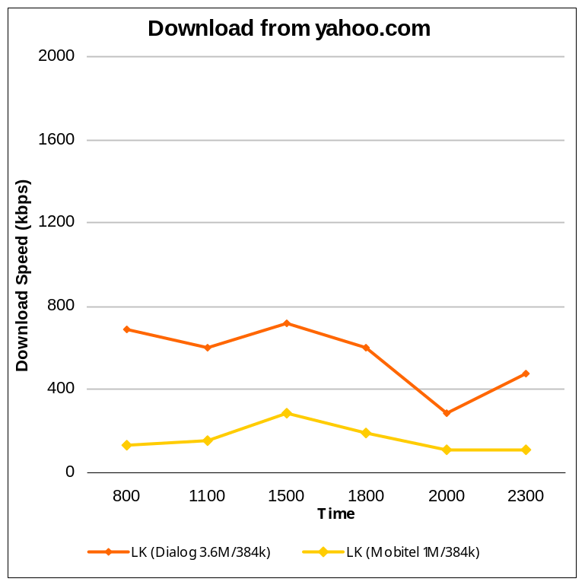

Figure 12 Figure 13
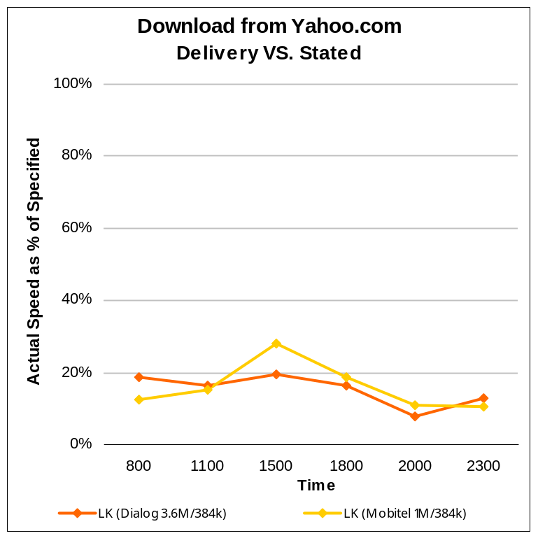
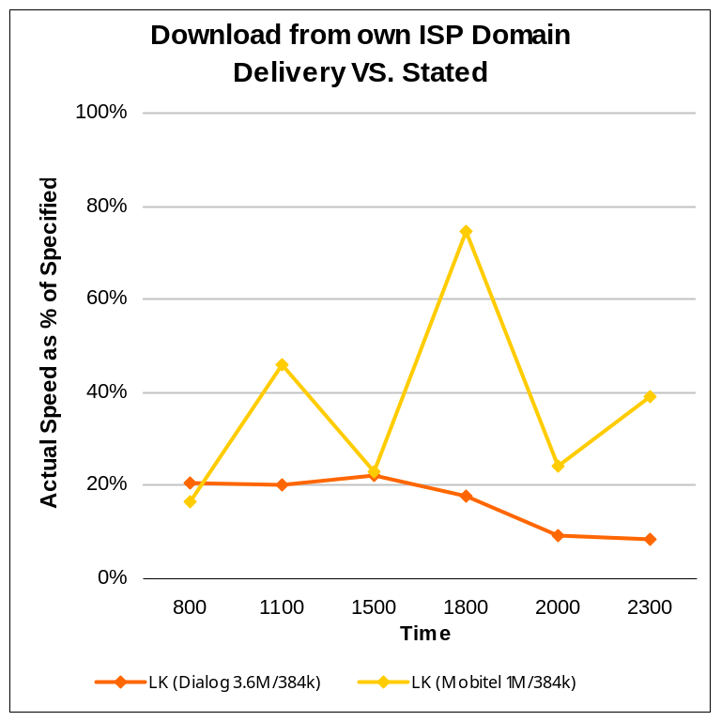
www.lirneasia.net

Maximum promised speed
Maximum promised speed

Mobile Broadband - JitterError: Reference source not found and Packet LossError: Reference source not found

Figure 14 Figure 15
www.lirneasia.net
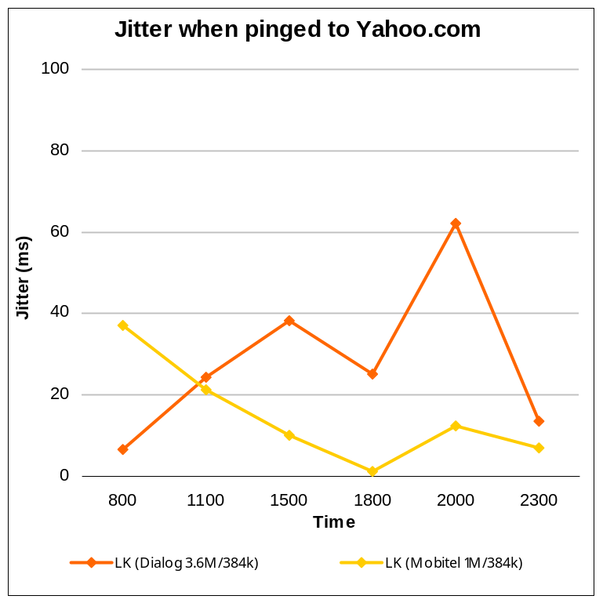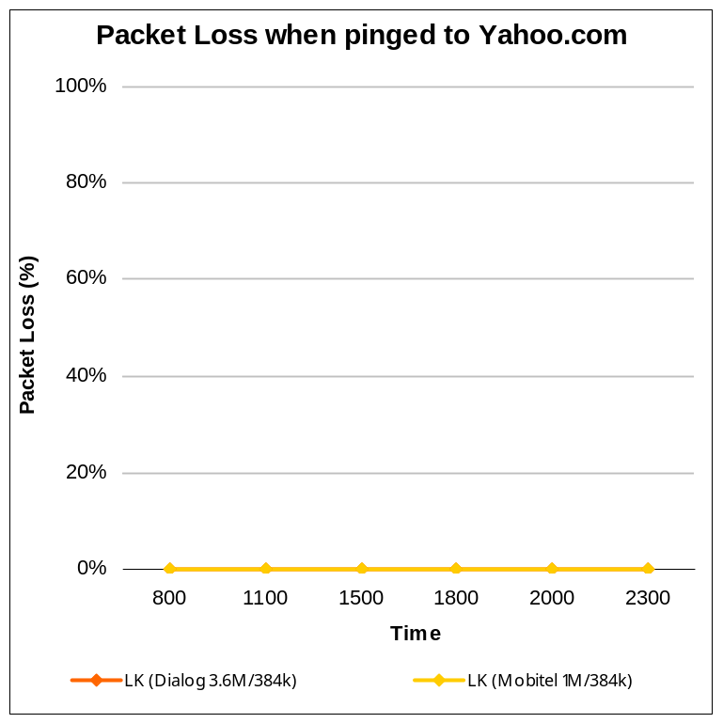

3%

Lower the better

Mobile Broadband - LatencyError: Reference source not found

Figure 16
www.lirneasia.net
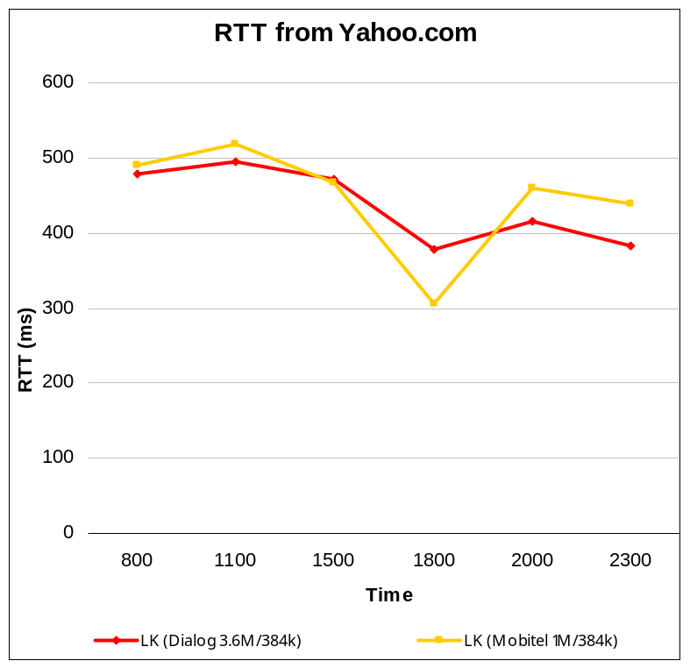

300ms

Lower the better

Prices quoted in local currencies have been converted to USD on the 23/10/08 using exchange rates quoted from http://www.domainit.com/currencyresults.html
Countries are ranked according to the GDP per capita obtained from the World Economic Outlook database, Oct 2007.
Cost of two tail charges + 96km link charge
In the event this specific package was not found the closest available package (at the next/fastest bandwidth or next download/upload limit) is reported.
Rates obtained from Afghanistan Telecom Regulatory Agency in October of 2007 quoted. More recent data not available at time of publication.
‘-‘ indicates that information was not available at time of research or package to closely fit the category could not be found.
TS2, http://www.ts2.pl/en/NSS-6
TS2, http://www.ts2.pl/en/NSS-6
No Offering at this speed is available. Nepal Telecom offers ‘Local point to point high speed data leased service’ at a lower speed of 64kbps. A 10km link is USD 514. See http://www.ntc.net.np/tariff/pstn_leased_charge.php
No Offering at this speed is available. However Nepal Telecom offers ‘National point to point high speed data leased service’ at the lower speed of 64kbps. A 100km link is priced at USD 1,296.86. See http://www.ntc.net.np/tariff/pstn_leased_charge.php
¹¹ Nepal Telecom, ADSL offerings, http://www.ntc.net.np/adsl/adsl_tariffPlans.php2
Nepal Telecom, ADSL offerings, there is no distinction between business and residential packages, http://www.ntc.net.np/adsl/adsl_tariffPlans.php
Office of the Bangladesh Telecom Regulatory Commission, Approval for Leasing or Sharing of Transmission Capacity (E1 etc), BTRC/SS/GP-Tariff/Part-1/2005-325, for a 30km link.
Sirius Broadband, Premium Package, 96-256Kbps. Information received from Sirius Broadband customer service.
Sirius Broadband, Xpress package, http://www.siriusbroadband.com/rate.php
Packages are based on time of use (off- peak, peak)
Pakistan Telecom Company Limited, 0- 200Km rate x 2, http://www.ptcl.com.pk/contentb.php?NID=43
Pakistan Telecom Company Limited, 0-200km rate x 100, http://www.ptcl.com.pk/contentb.php?NID=43
Pakistan Telecom Company Limited, DSL 2MB unlimited, http://www.ptcl.com.pk/contentp.php?NID=47
Pakistan Telecom Company Limited, DSL 512 Kbps Unlimited, There is no distinction between business and residential packages, http://www.ptcl.com.pk/contentp.php?NID=47
Micronet Broadband, DSL connect 9, 9GB, http://www.dsl.net.pk/VolumePackages.php
Micronet Broadband, 7GB, DSL@Home-7, http://www.dsl.net.pk/HomePackage.php
Mobilink, Infinity package, 5GB, http://www.mobilinkinfinity.com/tariff/
BSNL, 5km, http://www.bsnl.co.in/service/leased_tariff1.htm
BSNL, 100km rate, http://www.bsnl.co.in/service/leased_tariff.htm#high
MTNL, TriBand Broadband, Unlimited Plan -4, http://mumbai.mtnl.net.in/triband/htm/tariff.htm
MTNL, TriB Unlimited, UL data – 256, http://mtnldelhi.in/broadband/triband_tariff.htm
BSNL, Home UL 750 package, http://www.bsnl.co.in/service/dataone_tariff.htm
BSNL, Business 1200, 256kbps-2MB, 8 GB data limit, http://www.bsnl.co.in/service/dataone_tariff.htm#business1
BSNL, Home 250, 1GB Plan, http://www.bsnl.co.in/service/dataone_tariff.htm#business1
No Offering at this speed is available, However, TATA Indicom, Millennium Edition Plans (ME), 150kbps, 1GB Data Limit, is priced at USD 11.35, http://www.tataindicom.com/t-personal-internet-internetmobile.aspx http://www.tataindicom.com/t-personal-internet-internetmobile.aspx
Bhutan Telecom Ltd, 10km, http://www.druknet.bt/btelecom/index.php?option=com_content&task=view&id=35&Itemid=62
Bhutan Telecom Ltd, 100km, http://www.druknet.bt/btelecom/index.php?option=com_content&task=view&id=35&Itemid=62
Bhutan Telecom, Enterprise 2Mbps, 15GB, http://www.druknet.bt/btelecom/index.php?option=com_content&task=view&id=64&Itemid=112
Bhutan Telecom, Office – 256, 7GB, http://www.druknet.bt/btelecom/index.php?option=com_content&task=view&id=64&Itemid=112 http://www.druknet.bt/btelecom/index.php?option=com_content&task=view&id=64&Itemid=112
Bhutan Telecom Ltd, Home Package, 256kbps, http://www.druknet.bt/btelecom/index.php?option=com_content&task=view&id=64&Itemid=112
B-Mobile, Supreme, 1.2GB, 1Mbps, Call from customer service
Sri Lanka Telecom Rates for a 0-33km link. Price as quoted in Feb 2008
Sri Lanka Telecom Rates for a 33-99km link. Price as quoted in Feb 2008
Dialog, Office Net Package, 2Mbps/512kbps, http://www.dialog.lk/en/broadband/products/officenet.html
SLT, ADSL Home Express Package, 512/128kbps, http://www.slt.lk/data/forbusiness/115adsl.htm
SLT, Broadband entrée package, 512/128kps, http://www.slt.lk/data/forbusiness/115adsl.html http://www.websurfer.com.np/cable_internet_service.php
Mobitel, Zoom 1024, 1.5GB, http://www.mobitellanka.com/broadband/tariff.html
Dhiraagu, http://www.dhiraagu.com.mv/tariffs/dhivehinet.php#dedicatedaccess
ROL, Biz Broadband 2M, http://www.rol.net.mv/small-medium-biz/Biz-Broadband-2M.html
Dhiraagu, Biz unlimited, 512/128kbps, http://www.dhiraagu.com.mv/beta/business/small_medium/b_internet/biz_unlimited.php
ROL, Broadband 256k Value, http://www.rol.net.mv/home-user/ROL-Broadband-256k-Value.html
Dhiraagu, Biz Premier 4M, 4MB/512kbps, 10 GB data limit, http://www.dhiraagu.com.mv/beta/business/small_medium/b_internet/biz_premier.php
Dhiraagu, Biz Starter Package, 512/128kbps, 5GB, RF 0.25/MB, http://www.dhiraagu.com.mv/beta/business/small_medium/b_internet/biz_starter.php
Dhiraagu, Home Starter, Up to 512kbps, 1GB data limit, RF 0.25/MB, http://www.dhiraagu.com.mv/beta/internet/starter.php
Telkom, 5km, Siaran Pers No. 32/DJPT.1/KOMINFO/4/2008
Telkom, 100km, Siaran Pers No. 32/DJPT.1/KOMINFO/4/2008
ABLTECH, Soho package, http://abltech.com/price.html
Indosat, http://www.indosatm2.com/popup.php/promo/Bizz
PT Indosat, 3.6Mbps, 5GB, http://www.indosatm2.com/popup.php/promo/Bizz
PT Indosat, 'You!', 3.6Mbps, 1.2GB, http://www.indosatm2.com/popup.php/promo/prime
PLDT, http://www.pldt.com.ph/prod-serv/business/diginet.htm, information from Aug 2007.
PLDT, SmallBiz Micro, http://www.pldt.com.ph/prod-serv/business/bizdsl.htm
Globe Telecom, Trader lite, 384Kbps, http://www.sme.globe.com.ph/GlobeCSME/View/Content.aspx?eFtIJH3VkGkZ1MHH9FHehQ%3d%3d
Globe Telecom, wireless access, 384Kbps, http://www.globelines.com.ph/DataServices_HomeUse.php
No Offering available. Available packages are based on (limited by) hours of use and not downloadable capacity.
No Offering to match this package is available. However Globe Telecom, 256Kbps, 30 hours of usage is priced at USD 12.20. See http://www.globelines.com.ph/DataServices_BusinessUse.php
No Offering to match this package is available. However Globe Telecom, Plan 799, 1.8Mbps, 40 free hours of usage is priced at USD 16.38, http://www.globelines.com.ph/DataServices_BusinessUse.php
http://www.lirneasia.net/projects/current-projects/2241/.
Dodd, A. (2005), “The Essential Guide to Telecommunication” Fourth Edition, Pearson Education, p. 14
Dodd, A. (2005), “The Essential Guide to Telecommunication” Fourth Edition, Pearson Education, p. 60
Dodd, A. (2005), “The Essential Guide to Telecommunication” Fourth Edition, Pearson Education, p. 60
Connection Magazine, http://www.connectionsmagazine.com/articles/5/049.html, CISCO Press Article
The connections were tested on: SLT tested on : 21 Oct, 2008 & 22 Oct, 2008 Dialog tested on : 21 Oct, 2008 & 22 Oct, 2008 BSNL tested on : 22 Oct, 2008 & 24 Oct, 2008 Airtel tested on : 05 Nov, 2008 & 07 Nov, 2008 Sirius tested on : 18 Sep, 2008 SKYbd tested on : 24 Sep, 2008 Mobitel (HSPA) : 29 Oct, 2008 & 30 Oct, 2008 Dialog (HSPA) : 22 Oct, 2008
The speed at which the subscriber can receive traffic from the ISP server and a commonly used International Server (eg yahoo.com). It plays a significant role in responsiveness and real-time applications like VOIP.
Jitter is the variation of end-to-end delay from one packet to the next within the same packet stream/ connection/ flow. Jitter experienced in packets, more relevant in Real-time traffic like VOIP. Ideally it should be zero.
Number of packets (in %) that does not reach the destination. This can result in highly noticeable performance issues with Streaming Technologies, VOIP and Video conferencing.
Information not available for Sirius Broadband package
Time taken for traffic to reach a particular destination.
Maximum download speed for Dialog is noted as 3.6Mbps as this is the maximum capacity of the modem provided by the operator.

