# providing Affordable broadband of adequate quality throughout Sri LankA

**Policy Brief**

Providing broadband or any type of mobile network coverage is an absolute necessity if a country is to improve its economic growth. There are various technologies and methodologies that a government can implement in order to achieve this target. This document looks at some of those technologies and methodologies that can be used along with evidence and research to back up our recommendations.

**SUMMARY OF FINDINGS/ RECOMMENDATIONS**

1. The TRC should initiate a project in order to identify rural areas where broadband access is required and publish those details if not done so already. They should also waive off or give subsidies for the initial and monthly rental/s charged to telecom operators (telcos) for new sites for a given period of time.
2. The TRC should also implement a transmission infrastructure sharing mechanism. For example, installing a tower in a rural area in conjunction with all major telcos would result in the splitting of maintenance costs. The same would be implemented for transmission medium sharing as well. For example, rather than having multiple optical fiber cables or microwave links, a single cable or link can be used to share bandwidth on.
3. Once towers have been set up, creating a market for 3G and 4G services can be facilitated by introducing the benefits of using said technologies. Demand side stimulation should be developed further to solidify this recommendation.
4. The current mechanism for measuring broadband QoS (Quality of Service) is inadequate. To resolve this, the TRC should establish a standardized QoS measuring mechanism and make said details available to the general public.
5. Launch ICT training programmes and incubator programmes for those in rural areas to make the best use of broadband in their day to day activities, for example, with involvement of Sarvodaya Fusion.
6. The government should identify people who lack financial resources and provide them with subsidies and/or free broadband access in order to cultivate their skills and help boost the economy.
7. The government and related parties should make Sri Lanka open to R&D projects in order to further enhance the connectivity of affordable broadband to all areas of Sri Lanka. Expansion of the Google Loon project can also be added to this recommendation.

**THE RESEARCH**

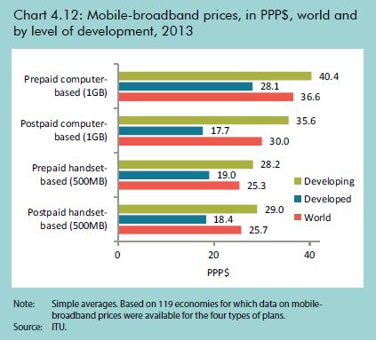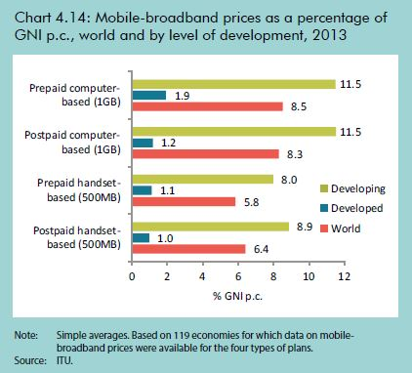

# Affordability

According to the TRCSL, for the year 2012, Sri Lanka was placed as No 1 in the world, with the lowest entry level fixed broadband charges, according to a report published recently by the International Telecommunication Union. So we have established that the broadband access in Sri Lanka is indeed affordable and the income of rural households should be able to afford a basic broadband connection.

As you can see from the figure on the right, as a country, Sri Lanka has one of the most affordable broadband prices is Asia.

Figure 1 Mobile Broadband Prices as a % of GNI and PPS (USD)

# Availability

The ITU defines broadband as a “transmission capacity that is faster than primary rate Integrated Services Digital Network (ISDN) at 1.5 or 2.0 Megabits per second (Mbits)”.

Axiata is currently working on an Infrastructure maintenance company that is charged with the sole purpose of installing and maintaining base stations/towers. This automatically would reduce maintenance cost of Telco operators and support transmission and medium sharing as well.

Adequate broadband can be provided either via optical fiber or microwave frequencies (dependent on how cost effective each method is) to towers. From that point onwards, consumers would have access to 3G or even 4G signals thus ensuring adequate speeds.

As a further step, the Government and TRC can open up Sri Lanka for R&D projects to test out new methods of providing broadband access thus making it available to all citizens of Sri Lanka. Since an MoU for Google’s Loon project has been signed, the Government and TRC can expand on this once it proves to be viable.

# Quality

According to a study conducted by Broadband Asia, the quality of a broadband connection can be dependent on a number of factors. They are:

* Throughput (Kbps) - Defined by the ITU as “an amount of user information transferred in a period of time”
* Latency (ms) Referred to as “delays when voice packets transverse the network”
* Jitter (ms) Referred to as “uneven latency and packet loss”
* Packet Loss (%) - Referred to as the number of packets (as a percentage) that does not reach the destination.

It is mandatory that the TRC provide methods that to the best of their abilities, alleviate jitter and packet loss in order to provide adequate broadband access whilst also ensuring a standard quality. Technologies such as packet marking can be used to prioritize traffic through protocols.

For services such as VoIP, highly reliable and scalable VoIP servers and equipment are required, but hardware alone will not be enough to maintain high-quality VoIP services. Adequate and stable network management software is also needed to observe fluctuating traffic, and rigorous and constant vigilance is needed to ensure the service is maintained to the highest levels.

It is also essential that the TRC and related agencies should establish a standardized QoS (Quality of Service) measuring mechanism to ensure adequate broadband speeds.

##### SOURCES

Fixed Broadband Charges: Sri Lanka ranks world’s lowest. (2012). Retrieved September 27, 2015, from http://www.trc.gov.lk/old_site/broadband/335-fixed-broadband-charges-sri-lanka-ranks-worlds-lowest.html

Income and Expenditure. (2013). Retrieved September 27, 2015, from http://www.statistics.gov.lk/page.asp?page=Income and Expenditure

Broadband Quality of Service Experience(QoSE). (n.d.). Retrieved September 27, 2015, from http://lirneasia.net/projects/2012-2014-research-program/ensuring-adequate-data-quality-for-bop-broadband-users/broadband-quality-of-service-experienceqose/

Measuring the Information Society Report 2014. (2014). Retrieved September 37, 2015, from https://www.itu.int/en/ITU-D/Statistics/Documents/publications/mis2014/MIS2014_without_Annex_4.pdf

**AUTHOR/S**

Isura Silva | General Manager, Sarvodaya Fusion | 726, Kotte Road, Athul Kotte, Sri Lanka | Tel 0714 481 934 | isura@fusion.lk | [www.fusion.lk](http://www.fusion.lk)

Buddika Wijetunga | Transmission Planning Engineer, Dialog Axiata PLC | 475, Union Place, Colombo 02, Sri Lanka| 0772 312477 | buddika.wijetunga@dialog.lk | [www.dialog.lk](http://www.dialog.lk)

Mahesh De Andrado | Writer, ReadMe | 200A 1/1 Kamathawatte Road, Meda Welikada, Rajagiriya, Sri Lanka| 0777 079261 | mahesh@readme.lk | [www.readme.lk](http://www.dialog.lk)