Every citizen should be included in the information society. The disabled remain excluded. This situation must change.
Policy Brief

The e-Sri Lanka initiative began in 2002. Today, all Government Ministries and Departments host websites, often in all 3 languages, and these host a variety of news and information about their functions, duties and services. A few, such as the Department of Motor Traffic, and the Colombo Municipal Council offer online payment facilities to the public. Accessing the Internet becomes easier with the introduction of more and more affordable smart phone handsets. However, there is one segment of the population that is not catered for; those with disabilities.
The total population of citizens with a disability of a form and nature that may limit their access to, and use of the Internet numbers 996,939. As with the able bodied people of this country, the aged (defined by the United Nations as those above 60 years of age) and those with disabilities should also have the power to freely access the information and services that the State provides online. This does however require the adoption of novel hardware, software and user skills. We feel it is important that these be made available to all.
SUMMARY OF FINDINGS/ RECOMMENDATIONS

- 996,939 citizens in Sri Lanka with impairments that hamper their access to the Internet. There isn’t a single Government website which is disable-friendly. With a few simple tweaks, these websites can be made more user friendly to this segment of society.

- An affordable micro computer unit such as The Raspberry Pi Foundation’s Raspberry Pi allows for an app to be installed, which will allow a disabled user to manipulate a computer, a tab or a smartphone.

- Nationwide hackathons and competitions can be held in order to encourage the development of the different types of apps, each of which can be installed in the device required in respect of each type of disability.
THE RESEARCH

- Each district should have at least one telecenter such as a Nenasela with a terminal with hardware and software that is disable-friendly. Alternatively, such a terminal could be located at the premises of a suitable disability focused organization, such as the Central Organization of the Deaf, Central Council of Disabled Persons.

- With devices and apps in place, the end users need to be trained to access the Internet themselves.

- A further app could be developed which would help to connect a user with an average smart phone to a helpdesk officer at the Government Information Hotline (1919). This way, he/she could ask the help desk officer to find information on his/her behalf.

- The Right to Information bill should include a clause to state that all Government information portals should be disable-friendly.

Over 150 Gosl websites; None of which are disable-friendly
All Government web portals in Sri Lanka are able to cater to those who read any of the 3 languages used in this country. This increases the number of people who will access Government information online. This is highly commendable. However, this does not cater to those with disabilities.
A rapid (4 day) online desktop research of websites providing reputable data and information, as well as face-to-face interviews with 2 final year IT students of the University of Moratuwa was carried out by the members of the team to ascertain the prevailing types of disabilities in the country, the existing tools and technologies available by which the disabled can access the Internet, and the tools and technologies used in other parts of the world to address this gap in connectivity.

Physical and mental conditions associated with disabilities are wide and varied

Figure 1. People with disabilities in Sri Lanka. Source: Dept of Census and Statistics, 2012
There is a broad range of physical and mental limitations which prevent such persons from accessing the Internet.

the world already has disable-friendly devises and software
Braille keyboards (Approx. USD 100), Braille displays (Approx. USD 8995), Magnifier screens (GBP 1600 upwards) and phones for the hearing impaired are a sample of a range of devices available to those with disabilities in the world. However, these are expensive. Some are even custom designed and built for special users, such as British Physicist Stephen Hawking and Australian motivational speaker Nick Vujicic. These are not deemed suitable for the larger Sri Lankan population, who may well be unable to afford such equipment.

Can One solution address all problems?
The difficulties associated with accessing the internet by those who are visually impaired would be different from those who are paralyzed. This in turn is different from those who are autistic. Those whose arms have been amputated, for instance, would face a different set of problems in accessing the Internet.
The Raspberry Pi Foundation of UK manufactures a processing unit called the Raspberry Pi, which runs on Artificial Intelligence (AI) technology. This is essentially a micro computer, which can be built into a suitable hardware device. For this, a software can be developed. Together, they can manipulate any device, including a computer, tab or smartphone. The IT professionals interviewed during our survey have spoken highly about this unit, and they have both used and developed code for it.
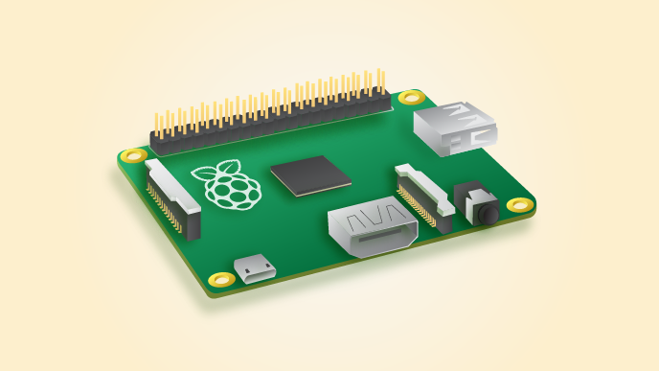
We see this as a very promising option by which to solve the hardware problems associated with accessing the Internet by those who need special tools for this purpose.

Each district should have at least one disable-friendly terminal by which to access the internet
Depending on the requirement, some districts may require more than 1 such terminal. Each of these locations should have a person who is trained in using these special terminals, and they should be able to teach and assist disabled users who visit.

Disabled people should have a special provision to access the internet via 9191
The Government Information portal should have officers who can be contacted via a specially designed app such as the Be My Eyes app, which can be installed on a smartphone. Through this system, a user can ask a helpdesk officer to seek information from any website on his/her behalf.

The right to information should be for all

Section 23 of the Protection of the Rights of Persons with Disabilities Act No. 28 if 1996 states that people shall not be discriminated on grounds of disabilities. The clause specifically mentions employment opportunities and access to places such as buildings.

Similarly, we strongly feel that the Right to Information Bill which is expected to be presented to Parliament soon should include a provision to ensure that efforts will be made, especially with regard to Government information, to ensure that all State websites be made accessible to citizens with physical and mental disabilities as well as those who are able bodied.

SOURCES

Population and Housing Census (2012). Report. http://www.statistics.gov.lk/PopHouSat/CPH2011/Pages/Activities/Reports/FinalReport/FinalReport.pdf

Health Statistics and Information Systems (2015). Web.
http://www.who.int/healthinfo/survey/ageingdefnolder/en/ (accessed September 2015)

AUTHOR/S

FORD COURSE, MARAWILA, GROUP NO. 4.
Ishara Madushanka | Infogate Institute | No.341/1, Main Street, Kantale | 0770677429 | madushankaishara@gmail.com | www.infogate.lk
Harshana Thushara Silva | Lankadeepa | Student at CMA | 0770474771 | thusharsilva58@gmail.com
Dushan Udugama | Nenasala-Bowatta | Mahagara, Udubaddawa | 0776539826 | dushanudugama@gmail.com
Radhika Wijesekera | LIRNEasia | No. 12, Balcombe Place, Colombo 8 | 0776583617 | radhika@lirneasia.net | www.lirneasia.net

https://www.afb.org/prodProfile.asp?ProdID=1666&SourceID=43
http://shop.adapt-it.co.uk/products/clearview-video-magnifier-colour-with-17in-tft-screen.asp
http://www.bemyeyes.org/
http://www.lawnet.lk/sec_process.php?chapterid=1996Y0V0C28A&sect ionno=23&title=Protection%20Of%20The%20Rights%20Of%20Persons%20With%20Disabilities&path=2

