WiFi Access to the Bottom of the Pyramid (BoP)

Policy Brief
This policy brief is to examine whether the Unified Payment Interface (UPI) is to be adopted by the Internet Service Provider for easy subscription of Wi-Fi access in India and the types of content to be hosted by the local community. We are giving this policy brief based on our study of TRAI policy paper 14/2016, various books, academic journals, newspapers, and websites. From our anlaysis, it is clear that the poor in both rural and urban areas particularly youth should be given free Wi-Fi access and the content can be of social, national and personal interests. UPI should not be mandatory as bulk of the users will not make any payments. Further, making UPI compulsory will constrain the service providers from using their choice of payment gateway – including cash.
Summary of Findings

- Bottom of the Pyramid requires information access to join the digital mainstream

- Given the inability of BoP to join the information ecosystem – device, access & monthly fees; government intervention to provide the device, access and initial awareness is necessary.
- The need to adopt Unified Payment Interface does not arise, as we are suggesting free Wi-Fi access
THE RESEARCH

NEED TO CONNECT THE BOP
Research across the world shows that access to technology especially internet and Smartphones can increase the GDP of a nation in a substantial way as shown in Figure 1 [1].
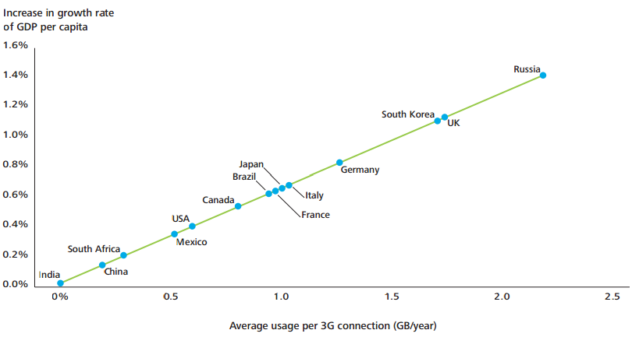
Fig 1: Average data usage per 3G on growth of GDP per capita
India can triple jump the industrial age backwardness in the digital age by providing Wi-Fi to its bottom of the national pyramid free of cost. The statistics of internet landscape of India in global map in comparison to other countries shows a miserable internet penetration as shown in Fig 2 [2]. India is going to have the largest number of youth in the world by 2020 and it is a great demographic dividend over other countries including China. This demographic advantage can be converted to an emerging economic power-house if the large number of youth can be utilized as productive work force with high value skilled output especially in ITES, rather than unskilled / low value output[4][5].

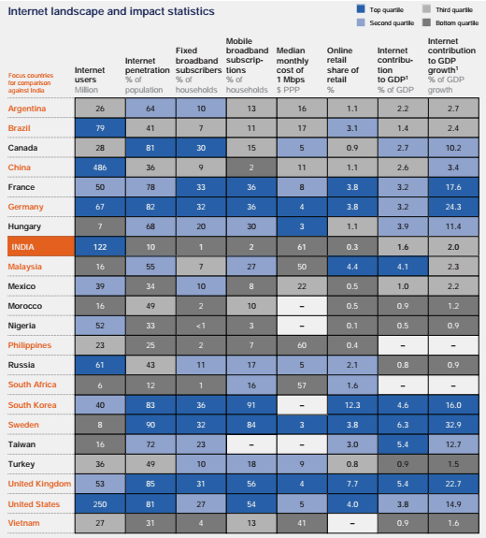
Fig 2: internet landscape of India in Global map
A vast majority of the unconnected are either residing in rural parts or are urban poor. In this context, it is pertinent to provide universal connectivity across the country. Once, the National Optical Fibre Network provides connectivity at each gram panchayat, the next goal is to connect the devices. Apart from issues of affordability of device and affordability of data package, it is foreseen that technology selection will play an important role. WiFi is seen as a potent alternative that will be cheap to implement due to its use of unlicensed spectrum. Moreover, it minimizes the capital intensive cabling work.
We live in the ‘Free Age’ where there is an increasing free offers day in and day out. Internet access, email, mobile phone services are coming free of cost WhatsApp, Wikipedia, email, search, blogs, e publishing etc In this ‘Free Age’ it is good to offer limited Wi-Fi access to the poor people in both rural and urban people. Those who can afford the costs can be offered unlimited Wi-Fi access for payment. Especially youth below 35 years can be targeted in the scheme which can be coined as “Hi-Fi Wi-Fi India”. We suggest that the partnership among Public, Private and Philanthropists suggested by Abramson et al [3] to give gadgets cum Wi-Fi access to those who cannot afford it. Tamil Nadu Government has been giving free laptops for the past 5 years. It has proposed to provide hi-fi broadband access to every household for a monthly pay of Rs.100/- (Illum Thorum Inaiyum – Internet for every household). We suggest that willing corporate companies may be tapped to provide Wi-Fi access to the poor. This can be their Corporate Social Responsibility. We support the Freemium model for Wi-Fi for the poor people, with first 20 MB data free every day, which can be accumulated for up to 7 days.
Unified Payment Interface of the National Payment Corporation of India provides a significantly smoother payment experience for payments initiated by either payee or payer. The interface is flexible to make possible payments over apps, websites, near field; with the help of QR code and other mechanisms. However, a simplistic UPI based interface will require 802.11u standard devices, for the devices to move between networks seamlessly. These devices are rare even in urban affluent settings, outside business travellers segment. It may take many years before it reaches the target segment of bottom of pyramid.
Thus, the decision to not force a payment interface is a conscious one. The entities that would charge over and above the free data pack should also be given the freedom to choose their mode of collection of payments, so as to suit their respective market realities. It is expected that when the inconvenience due to multiple payment interfaces becomes substantial, the providers of Wi-Fi services or aggregators will find a solution. Moreover, the ownership and regulation of payment platforms is under the purview of financial sector regulator Reserve Bank of India. RBI looks at broader issues than mobile connectivity. Therefore, the question of ownership and control of platforms cannot be answered through only the limited lens of telecom connectivity.

Local hosting of data

The rationale for local hosting is to reduce the price of data and connectivity is low to the end users. However, as first 20 MB data is to be given for free per day, the local hosting is not required. However, the local hosting may be undertaken to deal with eventualities of loss of connectivity from NOFN.
Community Service Centres (CSCs) [9] in every panchayat can host data of community interest. This can come free of cost supported by the CSR activities of local companies or the government. In case of the absence of the above two, the can be borne by the population collectively. Further, the local caching of contents is also open to private entrepreneurs, if there is a business model around it.

SOURCES
[1]Williams, Soloman,Peeper, “What is impact on mobile telephony on economic growth? A report for GSM Association” By Deloitte and CISCO, 2012
[2]Chandra Gnanasambandam et al, Online and upcoming: The Internet’s impact on India, McKinsey & Company, 2012.
[3] Alan Abramson, Benjamin Soskis, and Stefan Toepler , Public-Philanthropic Partnerships: Trends, Innovations, and Challenges George Mason University, Center for Nonprofit Management, Philanthropy, and Policy, 2012
[4] Report of Euromonitor International, India’s working-age population growing faster than China’s, 2010
[5] Report of the Committer on India Vision 2020, Planning Commission, Government of India, 2002
[6] Sunu Nair, Media for All (2015), Available at: http://ammaavinsaadhanaigal.com/media-for-all/
[7] Tatva Legal, An overview of CSR Rules under Companies Act, 2013, Hydrabad, 2014
[8] Telecom Regulatory Authority of India paper , Consultation Paper on Proliferation of Broadband through Public Wi-Fi Networks , Consultation Paper No. 14/2016
[9]A. Das, D. K. Banerjee, and K. Basu, Implementation of E-Learning in West Bengal to Enhance the Present GER in Higher Education, International Journal of Innovation, Management and Technology, Vol. 2, No. 3, June 2011

