Frequency Band De-licensing for the Proliferation of Wi-Fi

Summary of Recommendations
This group would like to recommend that:

  - Like in other countries more frequencies, particularly in the 5-6 GHz band, should be un-licensed for WLAN use. Specifically the 5.15-5.35 GHz, and 5.725-5.825 GHz should be considered for de-licensing
  - TV White Space (470- 582 Mhz) available with Doordarshan under Ministry of I&B should be un-licensed and be used as part of a mesh network with existing connectivity media until NOFN/BharatNet is completed

Background
In India the 27MHz band (Citizen Band) and the Wi-Fi range of 2.4 GHz and the 5.8 GHz range are unlicensed today.

It is an acknowledged fact that, Community Wireless Networks operating using unlicensed frequencies can facilitate initiatives like telemedicine, e-governance, e-commerce, e-learning, and telephony service through Voice over Internet Protocol (VoIP) thus serving the unreached at a much lower cost. However, both bands (2.4 GHz and 5.8 GHz) are highly congested thanks to ISPs shifting to these unlicensed bands. Additionally, equipment available for use in the 5GHz band use a large spectrum range and consequently alternative solutions from the limited other options available compromise the quality of service that can be provided and also restrict expansion in band.

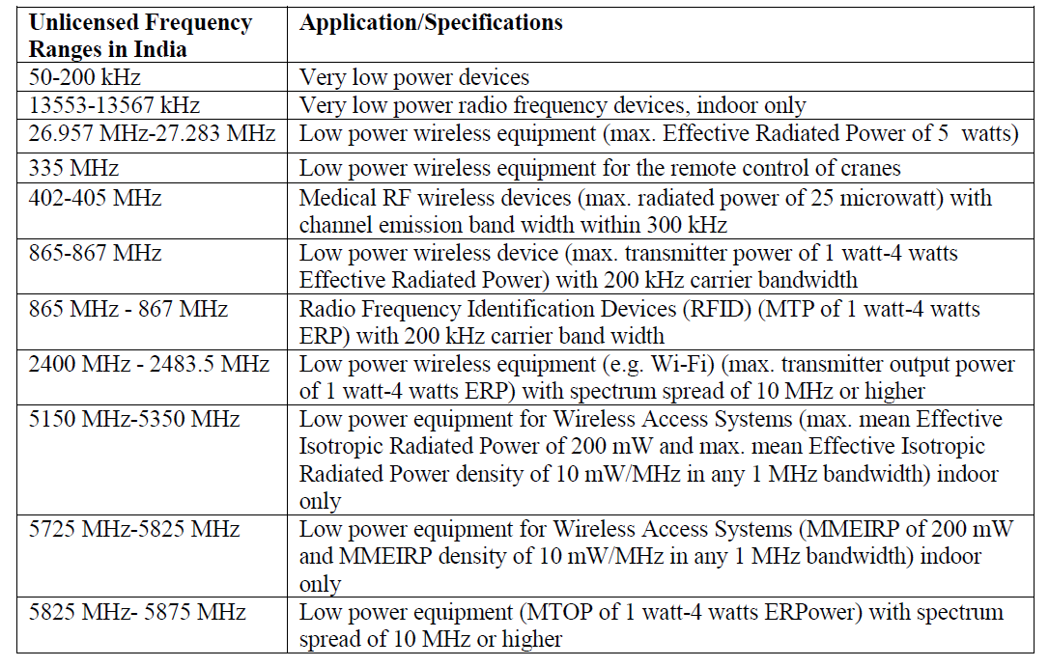
The NTP 2012 recognized the need for more un-licensed spectrum release.

In other countries, this problem has been recognized and suitable measures have been taken. Following the recommendations of the World Telecommunications Conference (WRC) in 2003, US, UK and Canada unlicensed spectrum in the 5-6 GHz range. The FCC subsequently de-licensed the 5.15-5.35 GHz and 5.725-5.825 GHz frequencies and also added 5.47-5.725 GHz to the unlicensed NII band.

In March 2003, EU advised its member states to de-license the 2.4 GHz and 5 GHz bands to administer public communication networks and services. The 433-434 MHz band has been unlicensed in Australia, Singapore, Malaysia, the European Union, and New Zealand

In Brazil, the TPC use in 5.150–5.725 GHz band is optional. DFS is required only in 5.470–5.725 GHz band. The MIIT in China has expanded and allowed channels to be de-licensed as of Dec 31 2012 to add UNII-1, 5150 ~ 5250 GHz, UNII-2, 5250 ~ 5350 GHz (DFS/TPC).

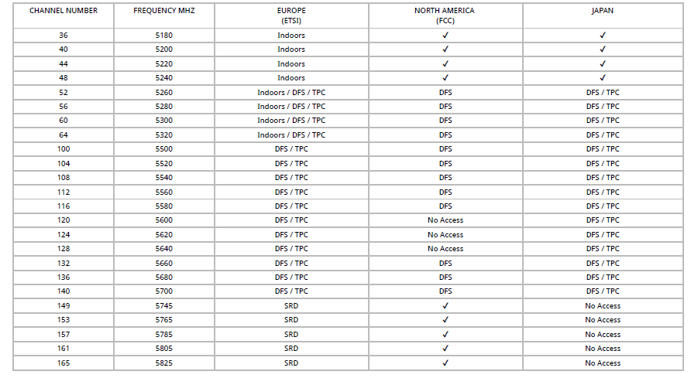

Measures and Solutions

Many industry bodies and advocacy groups in India have specific requests for unlicensed spectrum
The requests cover candidate bands including, 433-434 MHz, more bands in sub-1 GHz, more slots under the 2.4 GHz, 1880-1900 MHz, 5.15-5.35 GHz, and 5.725-5.825 GHz. Like in other countries more frequencies in the 5-6 GHz band could be un-licensed for WLAN use and many channels where only indoor use is permitted could be changed to cover indoors and outdoors.

It is also recommended that TV White Space available with Doordarshan be un-licensed as well. TV White Space 470- 582 Mhz- An alternative for large area Wi-Fi Hotspot. White Space refers to the unused broadcasting frequencies in the wireless spectrum. Television networks leave gaps between channels for buffering purposes, and this space in the wireless spectrum is similar to what is used for 4G and so it can be used to deliver widespread broadband internet. When analog TV channels switched to digital and when some broadcasters stopped their transmission, spectrum bands became available in various channels at different geographic locations. These spectrum holes are called as white spaces. The amount of white spaces available in countries such as US, UK, and Japan varies depending on the geographical locations.
In the US and the UK, regulators (FCC and Ofcom respectively) have permitted devices to make use of “white spaces” as a “secondary users” without causing interference to the “primary”, i.e., the TV broadcasting on a “license-exempt” basis. Low power license exempt operation on a “secondary basis” has been followed by FCC where the regulators would like to optimally utilize the spectrum which is otherwise utilized fully earlier for analog transmission, but now is part of “white spaces” due to the Digital Dividend. IIT Bombay conducted an empirical study on availability of vacant channels in the UHF TV transmission. They found that out of the 15 UHF TV channels (470-590 MHz), the average number of TV channels available for secondary usage is above 14 (112MHz), hence an ample amount of room is available for bandwidth utilization, as analog TV channels switched to digital and also some broadcasters stopped their transmission.
This white space can be utilized as a mesh network connecting back to the fibre in order to cover a wider area under wireless internet propagation. Currently, the Department of Telecom has decided not to allocate 470-582 MHz spectrum band for commercial deployment of TV White Space (TVWS) technology. The DoT is also of the view that this spectrum band should not be de-licensed and that the Centre will decide on the pricing for this spectrum in the future.

References
- https://www.ee.iitb.ac.in/tvws/ (Accessed Dec 2016)
- http://www.thehindubusinessline.com/info-tech/dot-says-no-to-releasing-tv-white-space-spectrum-clarifies-it-is-for- experiments/article8737575.ece (Accessed Dec 2016)
- http://www.radioelectronics.com/info/wireless/wifi/80211channelsnumberfrequenciesbandwidth.php(Accessed Dec 2016)
- Department of Telecommunications. Draft National Telecom Policy 2011
- Longford, G., & Wong, M. (2007). Spectrum Policy in Canada: A CWIRP Background Paper, pg. 2. Community Wireless Infrastructure Research Project. Retrieved November 23, 2011, from www.cwirp.ca/files/CWIRP_spectrum.pdf
- Commission Frees up Frequencies for Wi-Fi. (2005). EurActiv. Retrieved November 23, 2011, from http://www.euractiv.com/infosociety/commission-frees-frequencies-wifi/article-142740
- Carter, K. R., (2009). Unlicensed to Kill: a Brief History of the Part 15 Rules, pg. 13. Emerald Group Publishing Limited, 11(5), 8-18.
- Philip, J. T. (2007). Govt Delicenses 50 MHz of Spectrum in 5.8 GHz Band for WiMAX Use. The Economic Times. Retrieved November 30, 2011, from http://articles.economictimes.indiatimes.com/2007-02-19/news/28444412_1_ghz-wimax-services-isps
- "http://www.miit.gov.cn/n11293472/n11293832/n12843926/n13917072/15140529.html". Miit.gov.cn.
- Thomas, T. K. (2011, November 28). DoT May De-license Spectrum for Utility Services. Business Line. Retrieved November 30, 2011, from http://www.thehindubusinessline.com/industry-and-economy/info-tech/article2668933.ece?homepage=true&ref=wl_home
- "Brazil: Resolução nº 506, de 01/07/2008, publicado no Diário Oficial de 07/07/2008 (in Brazilian Portuguese)

Authors

- Arijit Das –Kolkata, India; +91 8587960547; arijit.das047@gmail.com
- Purva Grover- New Delhi, India; +91 8375804810; groverdpurva@gmail.com
- Suhas Ranjan – New Delhi, India; +91-7503139409; ranjan.suhas@gmail.com
- Nalini Srinivasan- New Delhi, India; +91-9910685082; nalini.srinivasan88@gmail.com

Department of Telecommunications. Draft National Telecom Policy 2011
http://www.radioelectronics.com/info/wireless/wifi/80211channelsnumberfrequenciesbandwidth.php

