AFFORDABLE TERMINAL DEVICES THAT ALL CAN USE, WITH SPECIAL ATTENTION BEING PAID TO THE ELDERLY AND DIFFERENTLY ABLED
Policy Brief
Out of 7 billion people in the world, more than one billion people live with some form of disability including old age population [1]. According to 2011 census, 1.94% of the total population of Nepal reported having some kind of disability and 2.2% are aged 60 and above. However, such group of people are unable to access the Information and Communication Technology and facilities either because it is not available in the national market or people do not have proper skill to use them.

Terminal devices are considered as such equipment that is used to do specific task in efficient manner built on top of ICT technology.. Since the digitally equipped ICT terminal devices privileges are available only in international market, we need to make favorable environment in order to import such devices and make it available for use of target group. In order to carry out this task fund need be allocated from government to purchase and distribute the terminal devices and applications to the needy persons either free of cost or with minimal cost. This document looks at some of the useful findings, recommendations and possible solutions to improve the lives of elderly and disabled people by facilitating most affordable technologies and applications.

[1] World Disability Report, WHO and WB Group,
http://whqlibdoc.who.int/publications/2011/9789240685215_eng.pdf

SUMMARY OF FINDINGS/ RECOMMENDATIONS

1. Use of Rural Telecommunications Development Fund(RTDF) for providing basic fixed, mobile and broadband services for persons with disabilities in both rural and urban areas assistive technologies. Launch pilot projects and programmes for funding accessible ICT projects like maintaining an accessible website and work with other telecom related government agencies to also have accessible websites.
2. Encourage the production of digital content that is of special interest to target group and make such content easily available.

3. Several technologies exist in the current market to make the lives of disabled and elderly people easier. Tailored hardware and software are required to assist such people who have deprived access to broadband and technology. In terms of software services following standards are proposed.

3.1. WCGA 2.0 standard should be followed in web content design which include screen readers, captioning services, and web page design features as consistent navigation mechanisms to make it user friendly.

3.2. DAISY consortium should be used to read and publish. It was formed in May 1996 by talking book libraries to lead the worldwide transition from Analog to Digital Talking Books.

3.3 Unicode Consortium need to be adopted for representing digital text on various platforms. It facilitates elderly people to read any content by assigning a unique code for every character

4.Followings are the possible hardware tools that could be used:
4.1 Sesame Phone(Sesame phone is touch free smartphone especially designed for people with disabilities that captures small head movements, tracked by its front facing camera.)
4.2 UNI (provides a two-way communication for the deaf people using speech and gesture technology)
4.3 Dot ( Dot is a wearable smartwatch that works for blind people and helps them to access tweets, messages anytime and anywhere right from their smartphones.)
4.4 HeadMouse Extreme(HeadMouse Extreme replaces the standard keyboard for the people who can’t make use of or have limited use of their hands. It translates the head movements into proportional mouse pointer movements and performs the respective operation. It works with Mac, Windows, Chrome, Android, Linux operating system.
4.5 Tactile Wand Electronic Stick(This electronic stick helps visually impaired people to determine the object that comes in their way. Tactile Wand Electronic Stick detects the object in front of the user and vibrates with the increasing intensity as soon as you get closer to it.
SUMMARY OF FINDINGS/ RECOMMENDATIONS
4.6 Finger Reader(Finger Reader is a wearable tool that helps in reading. The device helps visually impaired people to read any printed book or anything on any electronic device. Finger Reader includes a small camera that scans the text and provides real-time audio feedback of the detected words.)

5. United Nations Convention on the Rights of Persons with Disabilities (UNCRPD) clauses should be followed as far as practicable in national context.

According to CBS 2011,the data suggests that there are 2.94 percent of disabled population out total population, Furthermore, these groups becomes more vulnerable when any natural disaster occurs. Therefore to cope with such situations and improve resilience among the target group it is very important to introduce them to the available assistive technologies.
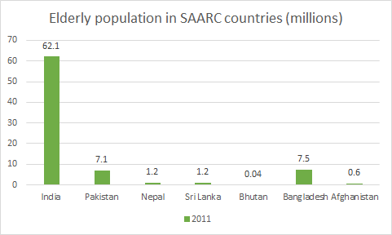

The Ministry of Social Security and Welfare of Nepal should identify all the technology required for disabled and elderly people and then they should collaborate with different INGOs and agencies which to avail the appropriate amount of funds to procure the devices required by disabled and elderly people.

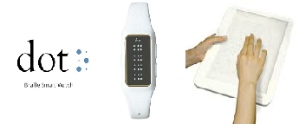

REFERENCES

- CBS. (2011). Census preliminary report. Kathmandu
- Pew Research Center's Internet & American Life Project surveys, 2011.
- PRB. (2007). World Population Data Sheet. Washington. Author
- UNCRPD Convention (2006).UN Headquarters.Newyork
- Verma .S(2017) ‘Electronic Devices For Specially Abled Persons’ Punjab: Scientific India
- World Disability Report (2010), WHO and WB Group

