Cool solutions: Climate change and the mobile phone

Rohan Samarajiva

Now that Al Gore’s got the Academy Award, everyone knows that we need to address climate change. This has actually become a national security imperative in Sri Lanka, because Elephant Pass and large areas of the currently fought-over areas of the North and East will go under water unless we cut down on greenhouse gases quickly. All that sacrifice will be wasted when the ocean moves in.

I will not get into the debate about who should cut down on greenhouse gas emissions, conceding that what little Sri Lanka does will not affect the outcome decisively. Instead, I will simply look at one small area that will help us to reduce our carbon footprint (a good thing to do in any case) and also improve the quality of our lives. Even if it makes no measurable impact on climate change and the waters will still rise, the actions that I propose will improve the quality of our lives in the time that we have before retreating to the hills.

Telecom-transport tradeoff

Transport of all kinds contributes to climate change. If we can reduce the time and money spent on transport, we can not only become more productive, but we can contribute to the fight against climate change. Given the price of fuel these days, we will also save a lot of money.

[insert slide 4 Greenhouse gas emissions]

Figure 1: Greenhouse gas emission projections in Sri Lanka to 2018 (transport sector contribution is second from bottom)
Source: Global Overlay Study of Greenhouse Gas Mitigation Options in the Sri Lanka Power Sector (taken from World Bank, Sustainable transport options for Sri Lanka, volume 1 of 3, p. 2. http://www-wds.worldbank.org/servlet/main?menuPK=64187510&pagePK=64193027&piPK=64187937&theSitePK=523679&entityID=000090341_20050504135227)

Even if one can afford the fuel to get from point to point, can one afford the time and aggravation? Table 1 shows what has happened to average speed of travel on the main approach roads into Colombo between 1997 and 2001. Given the massive number of new vehicles imported into the country during the good times of the ceasefire agreement, the average speeds must be even lower now.

[insert slide 5]

Table 1: Speed of travel (km/hr) at peak times on main approach roads into Colombo, 1997-2001
Source: Transport Studies Planning Centre, Ministry of Transport (taken from World Bank, Sustainable transport options for Sri Lanka, volume 1 of 3, p. 1. http://www-wds.worldbank.org/servlet/main?menuPK=64187510&pagePK=64193027&piPK=64187937&theSitePK=523679&entityID=000090341_20050504135227)

More and easier use of telecom should theoretically lead to less need to travel. But nothing is ever that simple.

Think of the paperless offices that we were promised with computers. What really happened was that paper consumption increased, until people figured out how to properly use the potential of the technology: e.g., people who got their underlings to print out their e-mails. Then, it decreased dramatically. In Sri Lanka, we have still not reached the decreasing stage in all offices.

Similarly, it is not realistic to think that improved telecom-based connectivity will immediately lead to a reduction in demand for transport and a reduction in greenhouse gases. But it is clearly a necessary action that will yield good results over time.

For telecom to make a real contribution to reducing demand for transport, several things need to happen
- Most people must have easy and convenient access to telecom, for sending as well as receiving messages and for retrieving as well as publishing information;
- All offices and business establishments must be reachable through telecom;
- They must change their business processes to reduce the need for people to physically come to their locations; and
- The ancillary infrastructures such as energy, payment, trust, verification and delivery systems must facilitate tele-transactions.

However, the necessary condition that is the foundation for everything else is access.

Access to telecom

In 2006, LIRNEasia conducted a five-country representative-sample survey, involving almost 9,000 respondents, of how people at the bottom of the pyramid (BOP) use information and communication technologies (ICTs). This is being repeated in 2008, but the results are not yet in.

This Teleuse@BOP study, which used quantitative methods including a diary in which people recorded each call made in a two-week period including purpose, duration, and cost, provided unique insights on teleuse at the bottom of the pyramid, defined as the two lowest socio-economic classification (SEC) groups (D and E) in each of the five countries (Pakistan, India, Sri Lanka, the Philippines and Thailand).

In Sri Lanka, the study accurately represented teleuse by 4 million Sri Lankans outside the Northern and Eastern Provinces, ages 18-60 in SEC D and E, with a margin of error less than 3 percent.

Ninety two percent of those approached (irrespective of SEC group) had used a telephone in the past three months. Of the users at the BOP in Sri Lanka, 41 percent owned the phone they had used. The others relied on friends, relatives, neighbors, and communication bureaus.

Both numbers are high, but not out of line with the facts. In 2003-04, the Central Bank’s consumer finance survey showed that 25 percent of all households in the country (except the Kilinochchi, Mannar and Mulativu districts) had some kind of phone, fixed or mobile. The Teleuse@BOP survey shows that, just two and a half years later, 41 per cent of the poorest households had some kind of phone in the house, indicating that the overall percentage of households with phones had grown fast. This is in line with industry developments in the past few years as shown by Figure 1: four times more connections (fixed and mobile) since 2002 than in the entire period before that.
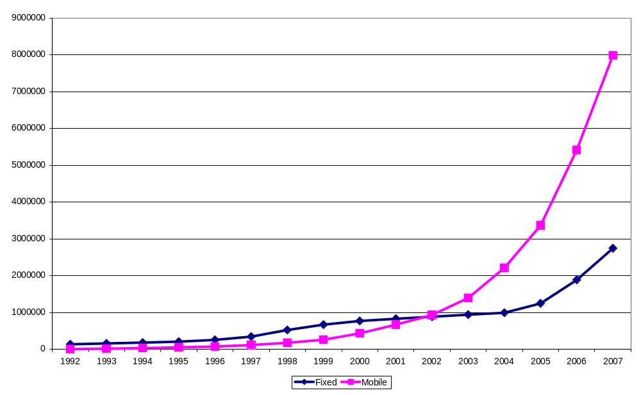
Figure 2: Fixed and mobile telephone growth in Sri Lanka, 1992-2007
Source: Telecom Regulatory Commission of Sri Lanka

LIRNEasia projects that 72 per cent of households at the Sri Lanka BOP will have phones by mid-2008.

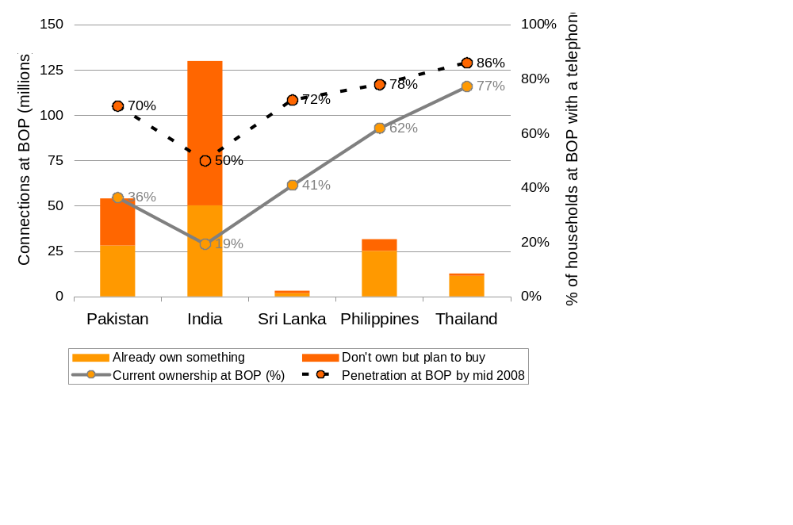

Figure 3: Current and projected connectivity at the BOP in Pakistan, India, Sri Lanka, the Philippines and Thailand
Source: LIRNEasia

Only one per cent at the BOP had used the Internet. Seventy percent had heard of the Internet but never used it, a much higher number than India (28 percent). What this means is that for those at the BOP in Sri Lanka, the functions of information retrieval using web browsers and downloads as well as publication of their own information in the conventional manner are out of the question at the moment. All they have is the ability to communicate, plus whatever rudimentary information retrieval and transaction services current mobile applications allow.

So it appears that Sri Lanka is on the way to satisfying the necessary condition for the telecom/transportation tradeoff and thereby contributing to the reduction of global warming. If the capabilities of mobile phones are extended, for example by allowing more sophisticated information retrieval and by improved voice commands, the condition may be fully satisfied.

What can be done in the short term?

More ways to avoid transport using the almost ubiquitous telephone connectivity must be developed. Two actions that may be taken by government and non-government actors are suggested here. These are, of course, only two examples.

Government action
An example of government action is the Government Information Centre (1919). Here, you can call a short code from within Sri Lanka and a conventional number from outside the country, 0800-2000 hrs 365 days of the year, and get information about many government services such as passports, national identity cards, pensions, and so on. Trained operators will respond in any of the official languages, drawing from computerized records of government procedures to either give the required information immediately or after inquiry.

This is an e-government application that is at the first stage, providing information only, not allowing for the completion of the required transaction. Yet, it is a massive improvement on the status quo, where people have to come repeatedly to government offices because they lack the necessary documents.

They will save time and money; the need for transport will be reduced; and the earth will be benefited.

If we can eliminate the need for trips to Colombo or regional centers using telecom to complete transactions it would be even better, but 1919 is an excellent start.

Non-government action
Another survey by LIRNEasia points to actions that may be taken by non-government actors. The survey found that vegetable farmers incurred significant information costs throughout the process of cultivation. Three key areas that were identified were the decision stage (where the farmer decides what to grow, based primarily on guesstimates of the prices that would be fetched at harvest time), the growing stage (where the farmer made repeated trips to town to find out whether subsidized fertilizer is available) and the selling stage. If better information was made available through the now almost ubiquitous phones, the information costs can be greatly reduced, primarily by cutting down on trips to town.

[insert slide 14]
Figure 4: Transaction costs in the agricultural value chain (non-information transaction costs: information costs)
Source: LIRNEasia

Does this mean that the Department of Agriculture should get into the business of providing information over the phone? Given the general track record of government in these matters, probably not. More helpful would be for the government to open itself up to various kinds of public-private partnerships to package the existing information into mobile-friendly form and to allow non-government actors to produce the needed information where it already does not exist.

For example, it will be necessary to collect prices in multiple markets at multiple times during a day to give farmers and traders the necessary information to sell their produce at the best prices. This will reduce price volatility and waste and improve farmer incomes and reduce consumer prices in the long run, as supply and demand get better aligned. More price data will have to be collected beyond the day-old averages from the largest markets reported in the media today; the price data will have to be made available through interactive voice response systems and SMS to farmers and traders who call in at any time of the day.

Price data are meaningless without the farmer having choice about where to sell and who to sell to. For farmers to have a choice about where to sell, it is necessary for them to have access to price data from multiple markets, not just Dambulla or Marandagahamula. If the farmer is tied to a specific trader because he obtained credit from him, price information is of limited value. This suggests that the credit market has to be improved as the market information system is upgraded.

Aggregation of market data collected in multiple locations can contribute to the improvement of credit markets by creating the conditions for greater use of forward contracts. As farmers enter into forward contracts, it will be possible to use them as collateral for credit, making it no longer necessary to obtain credit from traders. Greater use of forward contracts will of course reduce the importance of spot prices, which will now apply to a shrinking portion of the produce.

Forward contracts can also modulate the over-production of certain vegetables by farmers who emulate the crop-choice decisions of their neighbors. Simply informing a farmer that a particular crop fetched a good price in such and such month is not enough; he has to get also be given a sense of how much demand is likely to come to market when his crop is ready to harvest.

At a later stage, it may be feasible to complete the transaction online, either in the mobile space using the payment mechanisms now being developed for mobiles or from conventional Internet terminals. All that would then be required would be a location to take delivery, which has reliable and trusted electronic scales.

If these kinds of actions are taken by government and non-government actors, we can envisage a significant reduction in transport of humans as well as produce. Today, it is common for produce to be brought to Dambulla from Welimada and then transported back to Bandarawela. With improved market information the different markets will be integrated, reducing the need for these unnecessary trips. Again, farmers and traders will benefit from reduced transportation and the earth will benefit too.

Today, the agricultural markets in this country are inefficient; they do not clear, resulting in elephants getting to eat as much as 25 tons of vegetables on some days (figure 5). I am not sure what the environmental implications are of people instead of elephants eating those vegetables, but I do know that the farmers who grew those vegetables and the consumers who could have purchased those vegetables would be better off if the markets actually did clear. Efficient markets would probably allow us to leave more jungle uncleared so that the elephants can find their own food, without having to rely on the unintended results of inefficient markets.

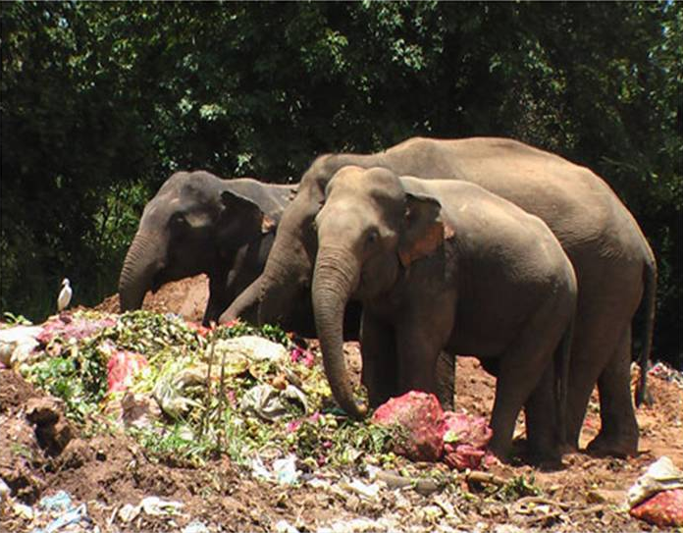

Figure 5: Elephants feasting on waste from the Dambulla market
Source: Lankadeepa, 20 March 2008, p. 1

Conclusions

Making the ec0nomy sustainable in the context of climate change is a large task. However, the near ubiquity of telephones in Sri Lanka offers us one easy place to start on reducing the harmful effects on the environment. If government and non-government actors make a concerted attempt to provide information and related services that will reduce the need for transport of humans and goods not only will the earth benefit from reduced greenhouse gas emissions, the quality of life of the citizens will improve. It is good to talk about Kyoto, but better to do practical things that will yield results in the short term.

Executive Director of LIRNEasia. This article draws heavily on LIRNEasia research. For those who want more detail, see http://lirneasia.net/projects/2006-07/bop-teleuse for more on the teleuse@BOP2 survey and http://lirneasia.net/projects/2006-07/icts-transaction-costs-traceability for more on the agricultural information research. The best source of information on the Government Information Centre (1919) is Galpaya, H., Samarajiva, R. and Soysa, S. (2007). Taking e-government to the bottom of the pyramid: Dial-a-gov?, Proceedings of the International Conference on Theory and Practice of Electronic Governance, Macau China, December 11, 2007 at http://www.lirneasia.net/wp-content/uploads/2007/12/galpayasamarajivasoysa_icegovv313.pdf

